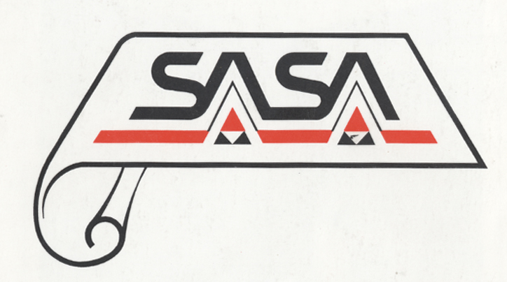

MEMBERSHIP APPLICATION FORM

THE SOUTH AFRICAN SOCIETY OF ARCHIVISTS (SASA)

Please return completed form by 23 January 2009 by e-mail to sasa@dac.gov.za or by fax to 086 569 8419 or post to SASA, c/o Private Bag X236, Pretoria 0001.

Surname:
Initials:
Known as (first name):
Title:

Job title (if applicable):

Employer (if applicable):

Field/s of specialization:

E-mail address:
Tel:
Cell:
Fax:
Postal address:

Qualifications:

Professional archival or records management experience:
[Please indicate nature of work and number of years of experience]

Would you be willing to be nominated for possible election to serve on the National Committee?

Any comments or suggestions regarding SASA:

Signature:
[Signature not essential if form is sent electronically]
Date:

